Tutorial 4 - SPM (wk 9 -Done)

Question 1
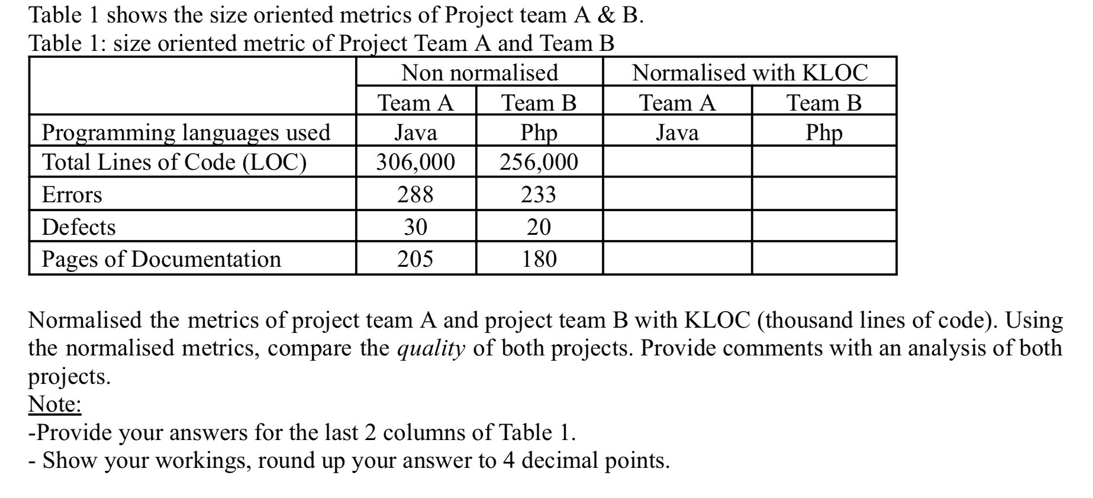
Team1
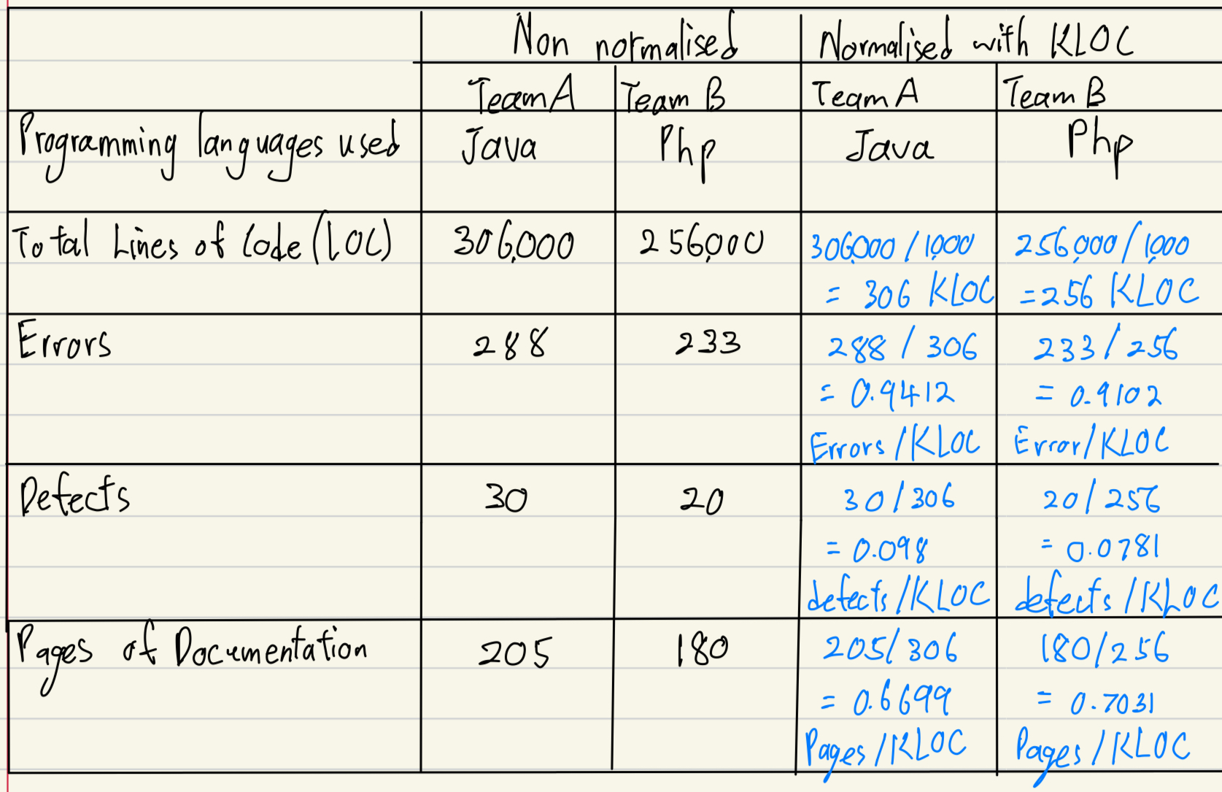
Comments：
TeamA has > errors than TeamB (0.9412 vs 0.9102)
TeamA has > defects than TeamB (0.0980 vs 0.0781)
TeamB has > pages of documentation than TeamA (0.7031 vs 0.6699)

Conclusion
Project B have higher quality based on:

Higher Correctness (Errors):
- Lower error per KLOC as compared to Project A
- Lower defects per KLOC as compared to Project A
Higher Maintainability (Documentation):
- Higher Page of Documentation, allowing the maintenance staff to maintain it easily, therefore it has higher quality of maintainability
Team 3

 | Non normalised |  | Normalised with KLOC
 | Team A | Team B | Team A | Team B
Programming languages used | Java | PHP | Java | PHP
Total Lines of Code(LOC) | 306,000 | 256,000 | 306000/1000=306 KLOC | 256000/1000=256 KLOC
Errors | 288 | 233 | 288/306 =0.9412  error/KLOC | 233/256 =0.9102  error/KLOC
Defects | 30 | 20 | 30/306 =0.0980  defect/KLOC | 20/256 =0.0781  defect/KLOC
Pages of Documentation | 205 | 180 | 205/306 =0.6699  pages/KLOC | 180/256 =0.7031  pages/KLOC
comments:
Team B’s project shows better quality and reliability than Team A’s. It has fewer errors and defects per 1000 LOC and more documentation pages, making it more reliable and maintainable compared to Team A’s project.


Team 4
 | Non Normalized |  | Normalized KLOC
 | Team A | Team B | Team A | Team B
Pro Languages | Java | PHP | Java | PHP
Total lines of code (LOC) | 306,000 | 256,000 | 306000/1000  =306 KLOC | 256000/1000  =256 KLOC
Errors | 288 | 233 | 288/306  =0.9412 error /KLOC | 233/256  =0.9102  error /KLOC
Defects | 30 | 20 | 30/306  =0.0980 defects / KLOC | 20 / 256  =0.0781  defects / KLOC
Pages of Documentation | 205 | 180 | 205 / 306  = 0.6699  pages/KLOC | 180/256  =0.7031  pages/KLOC
Comment:
Correctness(Errors)
On team B’s project, it has less errors made compared to Team A
(0.9102 < 0.9412). We can say that Team B has higher correctness due to low errors.
Maintainability(Pages of Documentation)
Team B has higher pages of documentation, compared to Team A
(0.7031 > 0.6699)
Team B has a higher quality of maintainability.
Conclusion:
Team B’s project has a higher quality.

Team 3
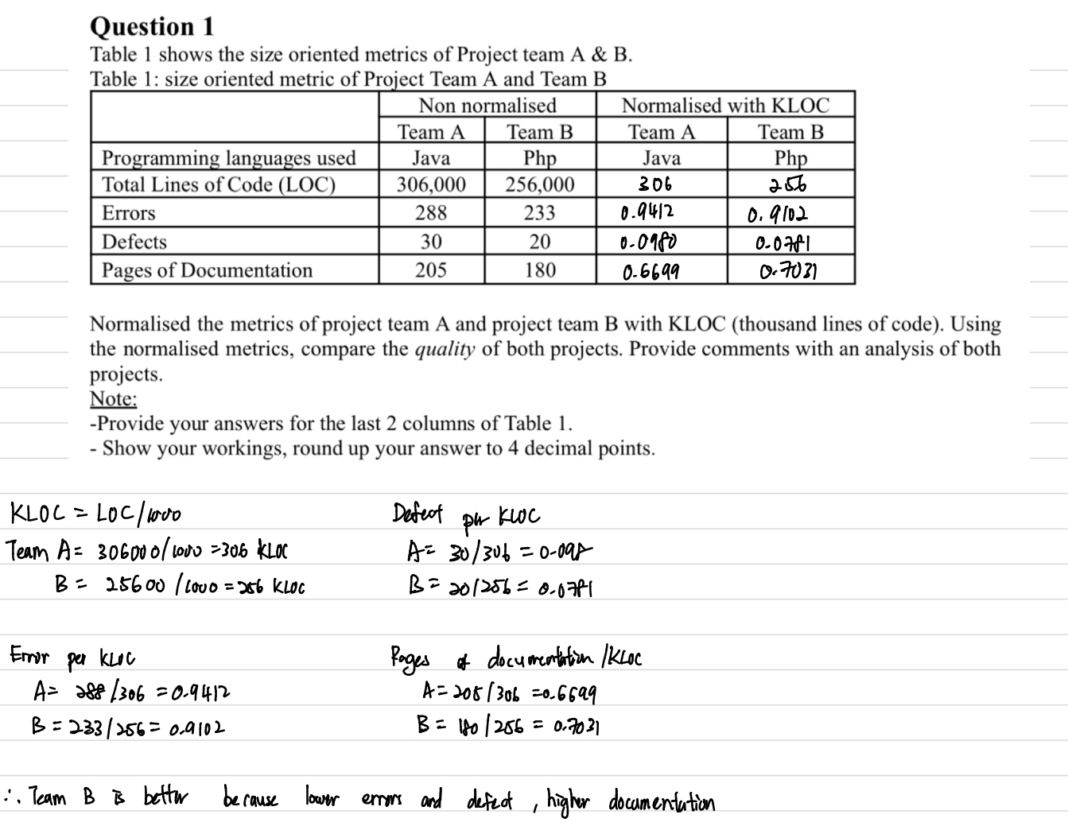
Conclusion
- project b has lower errors than project a which is 0.9102 vs 0.9412. Project b has better product quality.
- Project b has more documentation per KLOC than project a which is 0.7031 vs 0.6699. It means that the project b is support maintainability.
- Therefore, project b’s quality is higher than project a

Question 2
Team 3
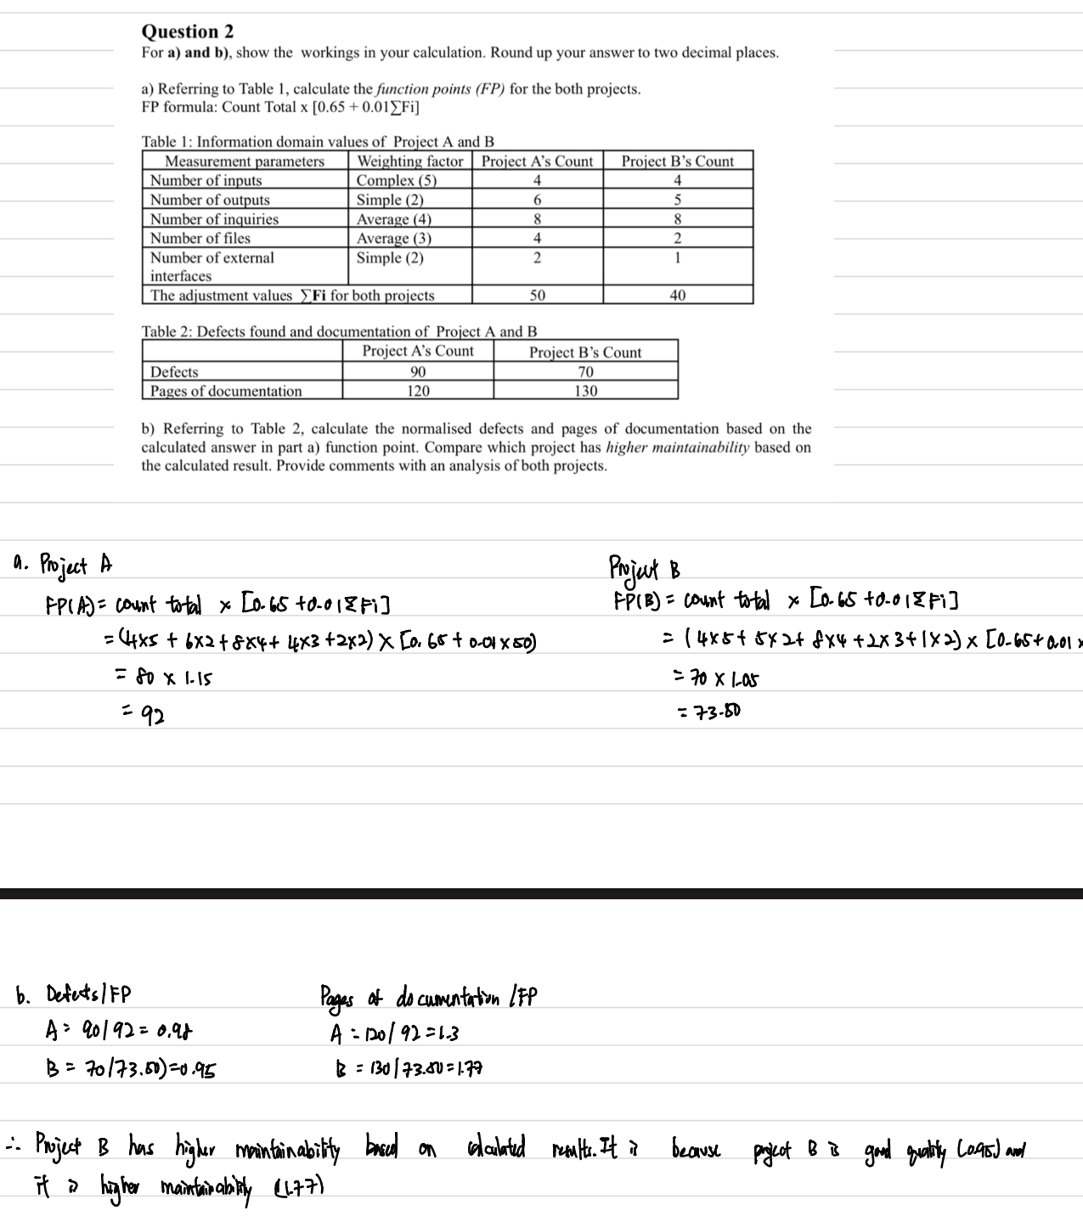
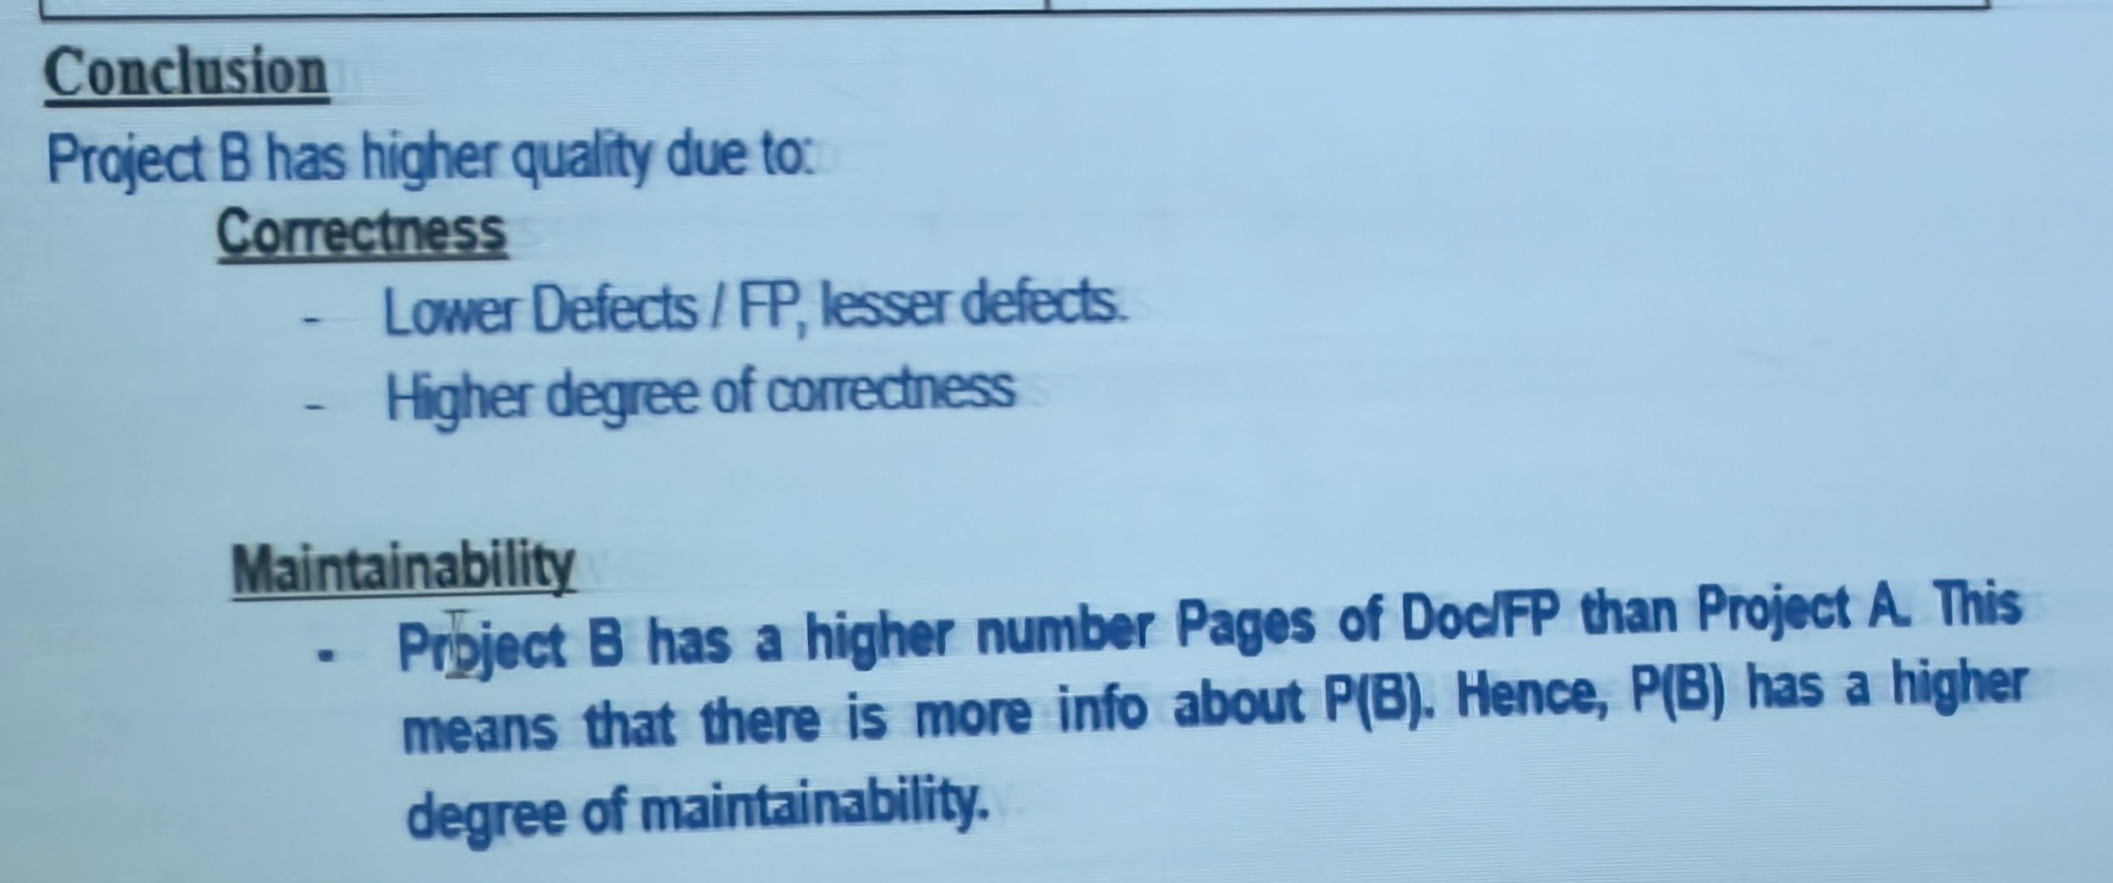

Question 3
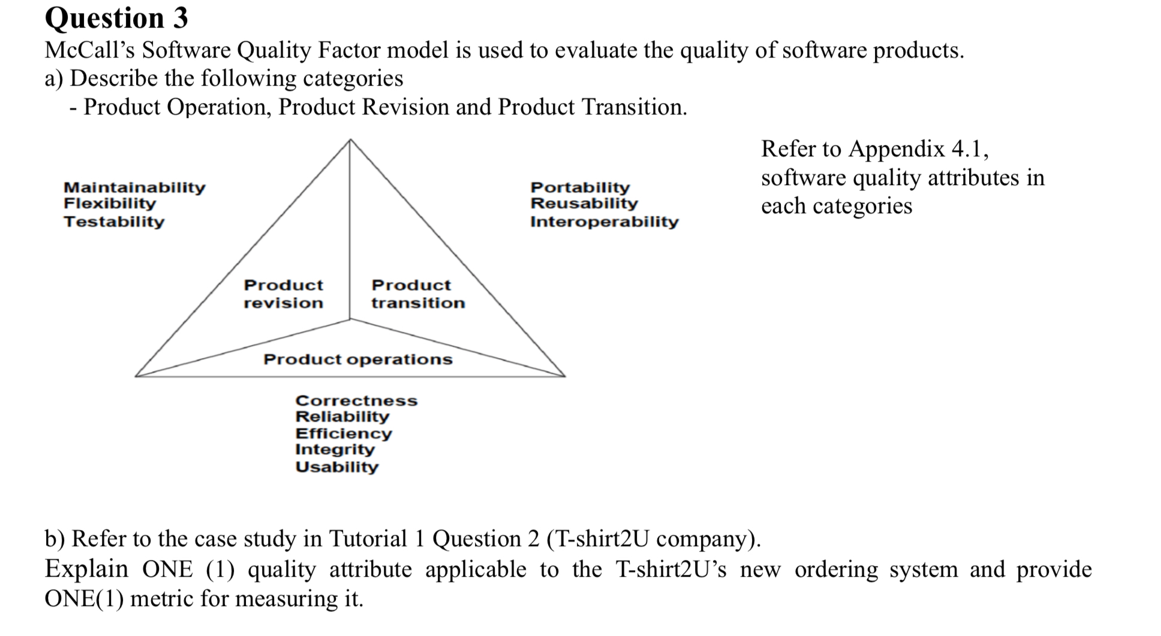
Product Operation
This category evaluates how well the software performs during the system execution. It focuses on attributes such as:
- Correctness – whether the software produces the expected results.
- Reliability – ability to operate without failure for a given time.
- Efficiency – use of system resources (CPU, memory, response time).
- Integrity – protection from unauthorized access (security).
- Usability – ease of use and user-friendliness.
Product Revision
This category is about how easy it is to make changes to the software after delivery. It emphasizes:
- Maintainability – effort needed to locate and fix errors.
- Flexibility – effort needed to adapt the software to new requirements.
- Testability – effort needed to verify modifications or improvements.
Product Transition
This category concerns how easily the software can adapt to a new environment or be reused. It includes:
- Portability – ability to run on different hardware/software platforms.
- Reusability – use of software components in other applications.
- Interoperability – ability to interact and exchange data with other systems.
B) Reliability (Product Operation)
Explanation: For T-shirt2U’s online ordering system, reliability is crucial because customers need the system to be consistently available when browsing products, adding items to carts, making online payments, and tracking fulfillment. Any downtime or failure could result in lost sales and prevent the company from achieving its business goal of increasing annual sales by RM50,000.
Metric: Mean Time Between Failures (MTBF)
- This metric measures the average time the system operates without a failure.
- A higher MTBF indicates greater reliability (e.g., aiming for 500+ hours between failures).
Alternative:
Lower number of errors and defects per function point

Question 4 (Team 4 (Team DNM) - Low Jian Hao present)
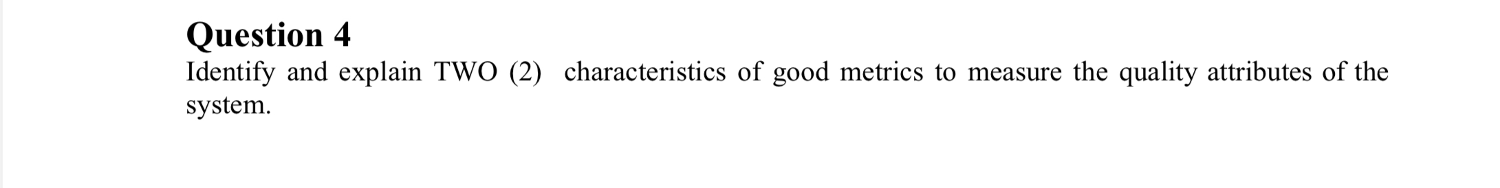

- Programming language independent
Metrics should be based on the analysis model, the design model, or the structure of the program itself. LOC is programming language dependent. (eg Assembly vs C++)

- Simple and computable
Relatively easy to learn how to derive the metric. Its computation should NOT demand excessive amounts of effort or time.

- Consistent in its use of units and dimensions
The mathematical computation of the metric should use measures that do not lead to bizarre combinations of units. E.g. use size and/or FP throughout all projects

Refer to Chp5 Slide 47 & 48 for other points

